Accept & enjoy the new situation and challenges, make positive contributions towards the given position, increase the wealth of the organization, and change the knowledge abilities, and skill through the organization by contribution



**About Me**

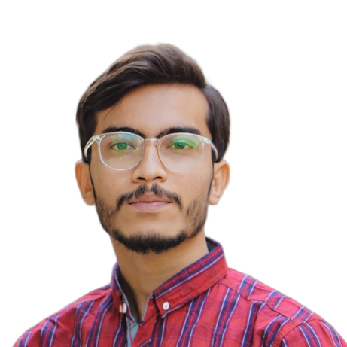

SYED SAAD ALI

**Education**

*WED DEVELOPER*

# MATRICULATION: Science

2016-2017



## Public School and College North Karachi



**Contact**

Sector 11C-2 North Karachi

 +923348214425

[syedsaadaly01@gmail.com](mailto:syedsaadaly01@gmail.com)

# INTERMEDIATE: Pre-Engineering

2018-2020



***Govt. Deg Sci/Com College Gulshan-e-Iqbal***

# BACHELORS: Computer Science



2021 - Present

## Sindh Madressa-tul-Islam University



**Work Experience**

**Ascent Communique**



As a Calling Agent



**Skills**

**HTML5 CSS3**

**JavaScript**